# Learning Objective

Turn Python program(s) into web application(s)/service(s) using Flask.

Introduction

Flask is a micro web framework written in [Python](https://en.wikipedia.org/wiki/Python_(programming_language)), which can be used to build websites and web applications.

For our purpose, we use Flask to allowPython functions to be called using URLs within HTTP clients such as web browsers and especially by other applications using HTTP methods.

# Install Flask

1. On your file system, create a project folder named hello_flask in C:\ESD\Labs (you will need to create these folders too)
2. Open a Command Prompt and change directory to the project folder:

**cd C:\ESD\Labs\hello_flask**

1. Use the following command to open the project folder in VS Code:

**code .**

Or by running VS Code and using **File** → **Open Folder**

1. Run **Terminal → New Terminal** (Ctrl+Shift+`) from the Command Palette, which creates a terminal
2. Use the following command in the VS Code terminal to install Flask:

**python -m pip install flask**

* If python does not work, try using python3.   
  E.g. **python3 -m pip install flask**
* If python3 works, replace python with python3 for **all** labs.

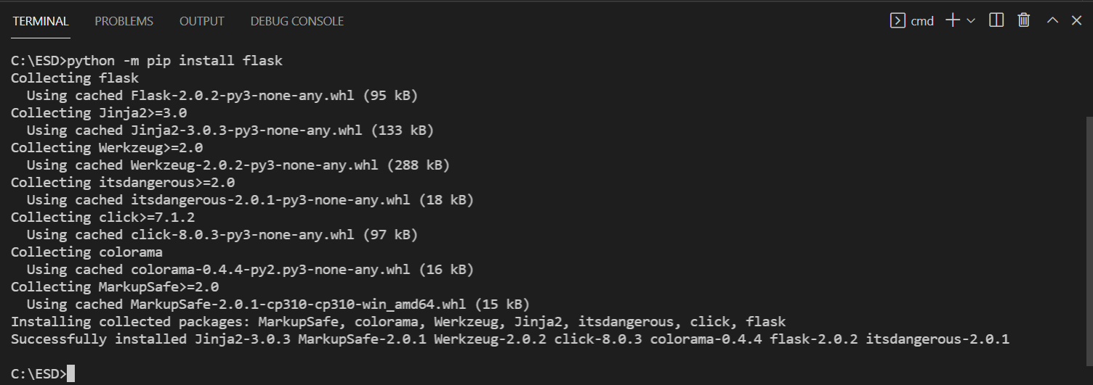

# Create and run a minimal Flask app

1. In VS Code, create a new file named **app.py** in your project folder using either **File** → **New** from the menu, pressing Ctrl+N, or using the new file icon in the Explorer View (shown below)

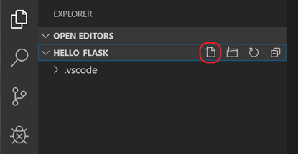

1. In app.py, add code to import Flask and create an instance of the Flask object:

from flask import Flask

app = Flask(__name__)

1. Below that, add a function that returns content, in this case a simple string, and use Flask's app.route decorator to map the URL route / to the function *home*:

@app.route("/")

def home():

return "Hello, Flask!"

*Note: To call the home() function, the URL to use would be http://<hostname>:<port>****/****. This would be constructed using the hostname of the computer it is being run on (in our case 127.0.0.1), the port (default 5000) and then the pattern specified in the app.route decorator (in this case* ***/****). For more information, see* [*Routing*](https://flask.palletsprojects.com/en/3.0.x/quickstart/#routing)*.*

1. Save the app.py file (Ctrl+S)
2. In the terminal, run the app by entering

**python -m flask run**

This runs the Flask development server. The development server looks for app.py by default. When you run Flask, you should see output similar to the following:

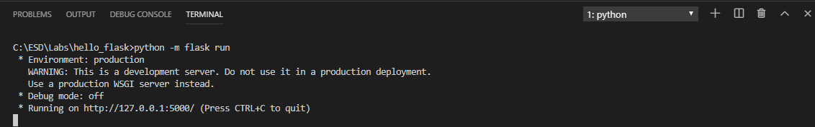

*Note: if you want to run on a different IP address or port, use the host and port command-line arguments, as with*

--host=0.0.0.0 --port=80

1. To open your default browser to the rendered page, Ctrl+click

the URL *http://127.0.0.1:5000/* in the terminal (or type the URL

in your browser)

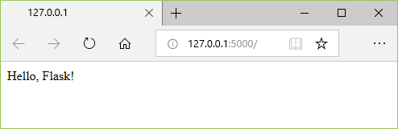

Observe that when you visit a URL like /, a message appears in

the debug terminal showing the HTTP request:



1. Stop the app by using Ctrl+C in the terminal

*Note: If you want to use a different filename than app.py, such as hello.py, define an environment variable[1] named FLASK_APP and set its value to your chosen file. Flask's development server then uses the value of FLASK_APP instead of the default file app.py. For more information, see* [*Flask command line interface*](https://flask.palletsprojects.com/en/2.0.x/cli/#)

Learning Points

* *Installing Python package(s) such as Flask*
* *Using Flask in Python program(s)*
* *Mapping URL(s) to Python function(s) using app.route decorator(s)*
* *Running Flask application(s) and calling the function(s) using a browser*

# Troubleshooting

### pip install flask fails

| *Error:* |
| --- |
| *Reason:* pip is a program (pip.exe) that is located with your Python installation. The PATH environment variable[2] is not set. This error tells you that it cannot find the program ‘pip’. |
| *How to fix:  If you know how to fix the PATH, do that, otherwise do this:*  *Follow* *this* *to fix the path on Windows  Uninstall your python installation, and follow the instructions from* [*Lab Preparations*](https://docs.google.com/document/d/1hSqhVbgbclf-eOvBx5BQhaTJHxbUSUN4wZTrLNUMyUk/edit?usp=sharing) *document.*  *Be sure to tick the checkbox at the bottom.*  Reopen the command prompt, visual studio code and try again. |

### No module named flask

| *Error:*  *You get this error even though you have installed flask via pip install flask* |
| --- |
| *Reason:* It could be that you have python 2 & python 3 in your system. Check by running:  python --version  python3 --version  If you see two versions, you have probably installed flask on python 2, which does not really support flask or something. |
| *How to fix:*  You are probably running on Mac or Linux to have this problem. Let us know if you are on windows and encounter this problem as well.  To fix this:   1. Open a terminal console 2. Edit your default terminal configuration file nano ~/.bash_profile 3. Add an alias into the file alias python=python3 alias pip=pip3 4. Save and close the file 5. Restart your visual studio code and/or terminal 6. Run this to install flask to python 3 python -m pip install flask 7. Run the program again to test python hello.py   Explanation:  What this does is you create an alias (an alternate name) to python. Previously python was pointing to python 2, and python3 is pointing to python3. So by setting this alias, when you type python, it will be like you are typing python3 instead. |

### Mac OS: <http://localhost:5000/> fails but <http://127.0.0.1:5000/> works

| macOS Monterey introduced AirPlay Receiver running on port 5000.  Please refer to <https://stackoverflow.com/questions/69818376/localhost5000-unavailable-in-macos-v12-monterey/69829313#69829313> on how to disable it. PDF copy of the web page [here](https://drive.google.com/file/d/1R1qYDGG2a7cEBpXBj1TmUgBWTaXIQ-Js/view?usp=sharing). |
| --- |

### *Python is newly installed and the environment variable PATH is set correctly but Python is not found.*

| *Error message*  Python was not found; run without arguments to install from the Microsoft Store, or disable this shortcut from Settings > Manage App Execution Aliases.  *Possible solution* Win start > type "Manage App Execution Aliases". Go to it and turn off   1. "App installer python.exe" 2. "App installer python*.exe"     Reference: <https://stackoverflow.com/questions/65348890/python-was-not-found-run-without-arguments-to-install-from-the-microsoft-store> |
| --- |

### *Error: Unable to install Flask*

*ImportError: cannot import name 'escape' from 'jinja2' (C:\Users\beata\anaconda3\lib\site-packages\jinja2\__init__.py)*

| Solution:  Upgrade pip :  python.exe -m pip install --upgrade pip |
| --- |

### Error: Unable to run app.py because of the below error -

*An attempt was made to access a socket in a way forbidden by its access permissions*

| Solution:  Use a different port to run app.py.  Ex: python -m flask run port = 5001  (using alternative method)  if __name__ == “__main__”:  app.run(port = ‘5001’) |
| --- |

### To add python path to environment variables on Windows

| * *Click the “Windows” key and type “environment” and you will see the option below. Click this “Edit the system environment variables”*      * *In the “System Properties” window, click “Environment Variables”*      * *Click “Path” under “User variables for <username>” and click “Edit”*      * *Check if you have a python path here, if not add it by clicking “New”. It should look like below.*      * + *You’ll need to add the path where you’ve your python installed.*   + *In “C:\Users\your_username” folder, if you do not see “AppData” folder, click View -> Select “Hidden Items”* |
| --- |

1. <https://www.digitalcitizen.life/simple-questions-what-are-environment-variables>
2. <https://www.digitalcitizen.life/simple-questions-what-are-environment-variables>